

# 

### Semester Two Examination, 2019

### Question/Answer booklet

# MATHEMATICS

If required by your examination administrator, please place your student identification label in this box

**METHODS**

**UNITS 3 AND 4**

## Section One:

## Calculator-free

|  |  |  |  |  |  |  |  |  |  |  |
| --- | --- | --- | --- | --- | --- | --- | --- | --- | --- | --- |
| Student number: In figures |  |  |  |  |  |  |  |  |  |  |

In words

Your name

## Time allowed for this section

Reading time before commencing work: five minutes

Working time: fifty minutes

## Materials required/recommended for this section

***To be provided by the supervisor***

This Question/Answer booklet

Formula sheet

***To be provided by the candidate***

Standard items: pens (blue/black preferred), pencils (including coloured), sharpener,  
correction fluid/tape, eraser, ruler, highlighters

Special items: nil

## Important note to candidates

No other items may be taken into the examination room. It is **your** responsibility to ensure that you do not have any unauthorised material. If you have any unauthorised material with you, hand it to the supervisor **before** reading any further.

## Structure of this paper

|  |  |  |  |  |  |
| --- | --- | --- | --- | --- | --- |
| Section | Number of questions available | Number of questions to be answered | Working  time (minutes) | Marks available | Percentage of examination |
| Section One:  Calculator-free | 8 | 8 | 50 | 52 | 35 |
| Section Two:  Calculator-assumed | 13 | 13 | 100 | 98 | 65 |
|  | | |  | **Total** | 100 |

|  |  |  |
| --- | --- | --- |
| Markers use only | | |
| Question | Maximum | Mark |
| 1 | 4 |  |
| 2 | 7 |  |
| 3 | 7 |  |
| 4 | 6 |  |
| 5 | 7 |  |
| 6 | 8 |  |
| 7 | 7 |  |
| 8 | 6 |  |
| S1 Total | 52 |  |
| S1 Wt (×0.6731) | 35% |  |
| S2 Wt | 65% |  |
| Total | 100% |  |

## Instructions to candidates

1. The rules for the conduct of examinations are detailed in the school handbook. Sitting this examination implies that you agree to abide by these rules.

2. Write your answers in this Question/Answer booklet preferably using a blue/black pen.  
Do not use erasable or gel pens.

3. You must be careful to confine your answer to the specific question asked and to follow any instructions that are specified to a particular question.

4. Show all your working clearly. Your working should be in sufficient detail to allow your answers to be checked readily and for marks to be awarded for reasoning. Incorrect answers given without supporting reasoning cannot be allocated any marks. For any question or part question worth more than two marks, valid working or justification is required to receive full marks. If you repeat any question, ensure that you cancel the answer you do not wish to have marked.

5. It is recommended that you do not use pencil, except in diagrams.

6. Supplementary pages for planning/continuing your answers to questions are provided at the end of this Question/Answer booklet. If you use these pages to continue an answer, indicate at the original answer where the answer is continued, i.e. give the page number.

7. The Formula sheet is not to be handed in with your Question/Answer booklet.

Section One: Calculator-free 35% (52 Marks)

This section has**eight (****8)** questions. Answer **all** questions. Write your answers in the spaces provided.

Working time: 50 minutes.

Question 1 (4 marks)

Determine the following:

(a) $\int_{ }^{ }{\underset{ }{\overset{ }{12{(2x+1)}^{2}}}}dx$. (2 marks)

(b) $\begin{matrix}d \\ \overline{dx}\end{matrix}\cos\left(2x+1\right)$. (1 mark)

(c) $\begin{matrix}d \\ \overline{dx}\end{matrix}\int_{3}^{x}{\underset{ }{\overset{ }{(2t+1)}}}dt$. (1 mark)

Question 2 (7 marks)

The velocity of a small body moving in a straight line at time $t$ seconds is given by

$$v=\frac{8}{1+t} \text{m/s}, t≥0.$$

(a) Determine the velocity of the body when its acceleration is m/s2. (4 marks)

(b) Calculate the distance travelled by the body in the first $3$ seconds. (3 marks)

Question 3 (7 marks)

(a) Write $1+\log_{5}{3}-2\log_{5}{7}$ in the form $\log_{5}{k}$. (3 marks)

(b) Solve for $x$ the equation $e^{x-2}=\sqrt{3}$. (2 marks)

(c) Determine $\begin{matrix}d \\ \overline{dx}\end{matrix}\left(\log_{e}\left(\begin{matrix}1 \\ \overline{{5x}^{2}+1}\end{matrix}\right)\right)$. (2 marks)

Question 4 (6 marks)

Let $f(x)=\sqrt{3}\cos\left(\begin{matrix}x \\ \overline{2}\end{matrix}\right)$ and $g(x)=\sin\left(\begin{matrix}x \\ \overline{2}\end{matrix}\right)$.

The shaded region on the graph below is enclosed by $x=0,$ $y=f(x)$ and $y=g(x)$.

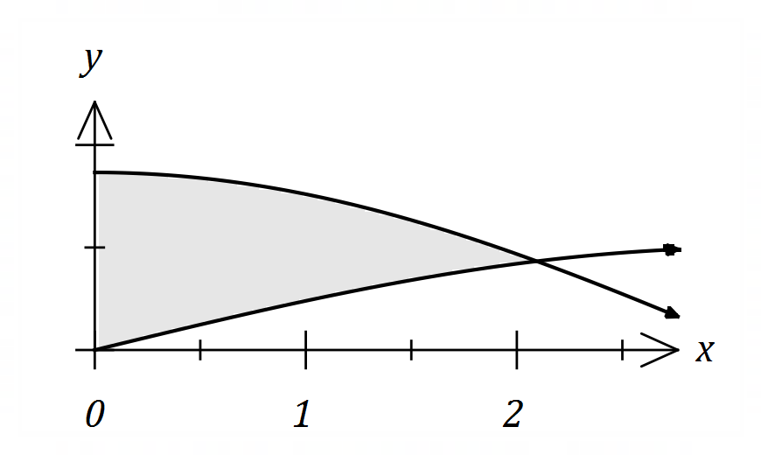

(a) Show that $f\left(\begin{matrix}2π \\ \overline{ 3 }\end{matrix}\right)=g\left(\begin{matrix}2π \\ \overline{ 3 }\end{matrix}\right)$. (2 marks)

(b) Determine the area of the shaded region. (4 marks)

Question 5 (7 marks)

The random variable $X$ has probability density function $f\left(x\right)$ shown below, where $k$ is a positive constant.

$$f\left(x\right)=\left\{\begin{matrix}kx+\frac{1}{20} & & 0≤x≤4 \\ 0 & & \text{elsewhere}\end{matrix}\right.$$

(a) Deduce that $k=\begin{matrix}1 \\ \overline{10}\end{matrix}$. (3 marks)

(b) Determine the value of $a$ if $P\left(1<X<a\right)=\begin{matrix}1 \\ \overline{5}\end{matrix}$. (4 marks)

Question 6 (8 marks)

Let $f\left(x\right)=\left(1-x\right)e^{-2x}$.

(a) Determine the coordinates of the stationary point of the graph of $y=f(x)$ and use the second derivative test to determine its nature. (6 marks)

(b) Determine the coordinates of the point of inflection of the graph of $y=f(x)$. (2 marks)

Question 7 (7 marks)

In a class of $25$ students, $20$ are right-handed.

(a) One student is selected at random from the class and the random variable $X$ is the number of right-handed students in the selection. Determine the mean and standard deviation of $X$. (3 marks)

(b) Two students are selected at random from the class without replacement and the random variable $Y$ is the number of right-handed students in the selection.

(i) Complete the probability distribution table below. (3 marks)

|  |  |  |  |
| --- | --- | --- | --- |
| $$y$$ | $$0$$ | $$1$$ | $$2$$ |
| $$P(Y=y)$$ |  |  |  |

(ii) Determine $E(Y)$. (1 mark)

Question 8 (6 marks)

Let $f\left(x\right)=\begin{matrix}x \\ \overline{x+1}\end{matrix}$.

(a) Determine $f(x)$ and $f(x+δx)$ when $x=70$ and $δx=5$. (1 mark)

(b) Use $f(x)$ and the increments formula to estimate the difference between $\begin{matrix}89 \\ \overline{90}\end{matrix}$ and $\begin{matrix}92 \\ \overline{93}\end{matrix}$.

(5 marks)

Supplementary page

Question number: _________

© 2019 WA Exam Papers. Kennedy Baptist College has a non-exclusive licence to copy and communicate this document for non-commercial, educational use within the school. No other copying, communication or use is permitted without the express written permission of WA Exam Papers. SN245-145-1.